Alert Dialog :

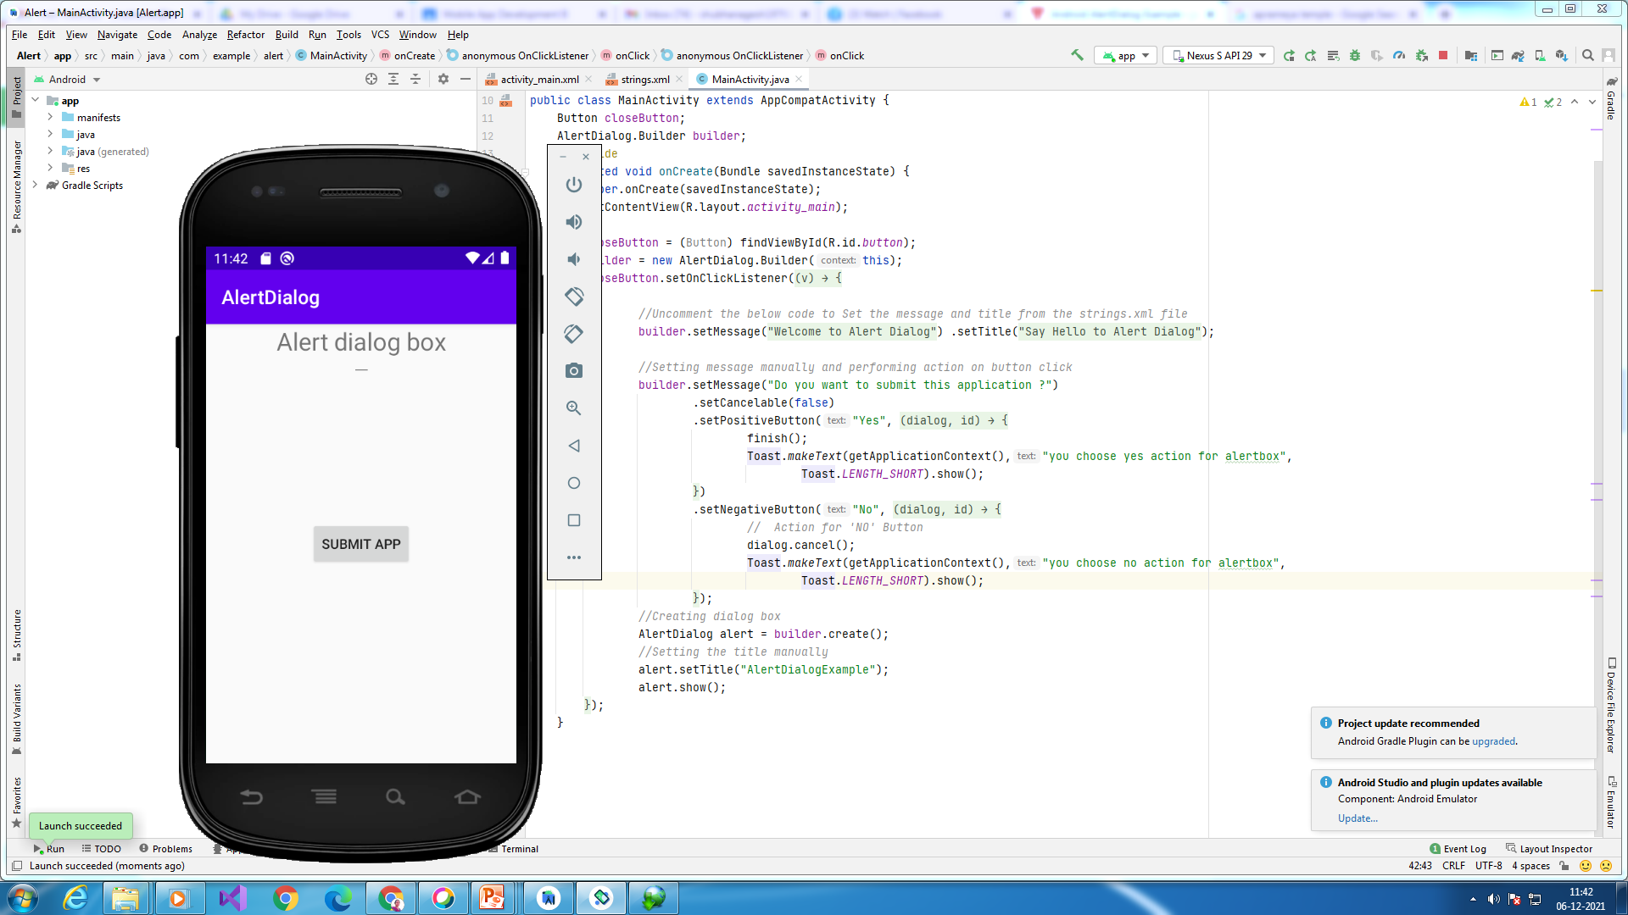

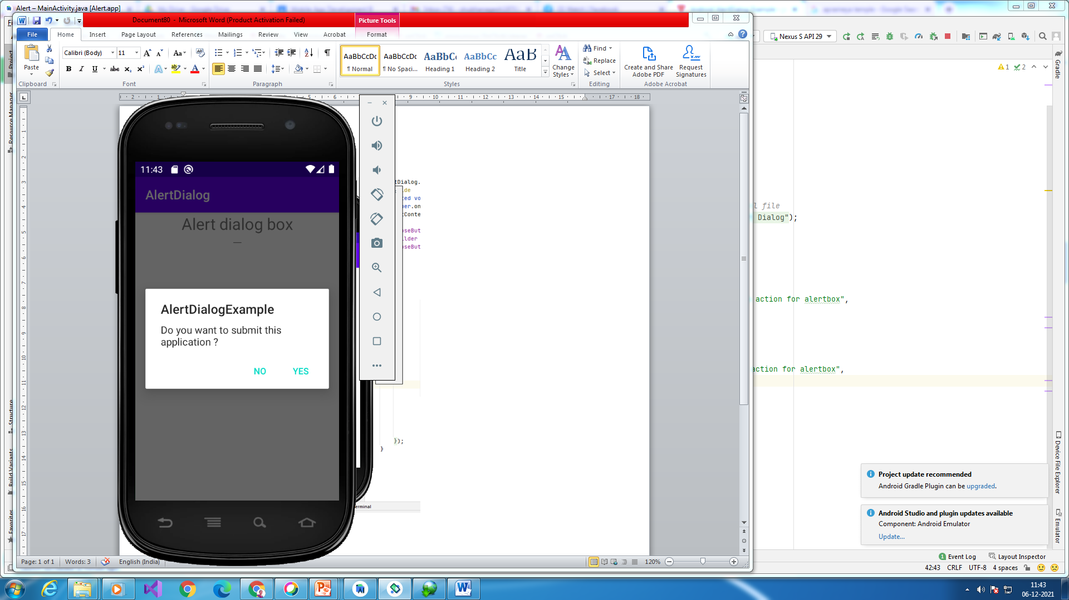

*<?*xml version="1.0" encoding="utf-8"*?>*<androidx.constraintlayout.widget.ConstraintLayout xmlns:android="http://schemas.android.com/apk/res/android"  
 xmlns:app="http://schemas.android.com/apk/res-auto"  
 xmlns:tools="http://schemas.android.com/tools"  
 android:layout_width="match_parent"  
 android:layout_height="match_parent"  
 >  
 <TextView  
 android:id="@+id/textView1"  
 android:layout_width="fill_parent"  
 android:layout_height="wrap_content"  
 android:gravity="center_horizontal"  
 android:textSize="25dp"  
 android:text="Alert dialog box"  
 android:layout_alignParentTop="true"  
 android:layout_alignParentLeft="true"  
 android:layout_alignParentStart="true" />  
  
 <EditText  
 android:id="@+id/textView"  
 android:layout_width="wrap_content"  
 android:layout_height="wrap_content"  
 android:layout_centerHorizontal="true"  
 android:textAppearance="?android:attr/textAppearanceSmall"  
 android:textSize="25dp"  
 app:layout_constraintEnd_toEndOf="parent"  
 app:layout_constraintStart_toStartOf="parent"  
 tools:layout_editor_absoluteY="172dp" />  
  
 <Button  
 android:layout_width="wrap_content"  
 android:layout_height="wrap_content"  
 android:id="@+id/button"  
 android:text="Submit app"  
 app:layout_constraintBottom_toBottomOf="parent"  
 app:layout_constraintLeft_toLeftOf="parent"  
 app:layout_constraintRight_toRightOf="parent"  
 app:layout_constraintTop_toTopOf="parent" />  
  
</androidx.constraintlayout.widget.ConstraintLayout >

String.xml

<resources>  
 <string name="app_name">AlertDialog</string>  
 <string name="dialog_message">Welcome to Alert Dialog</string>  
 <string name="dialog_title">Say Hello to Alert Dialog</string>  
</resources>

.java code

package com.example.alert;  
import androidx.appcompat.app.AppCompatActivity;  
import android.os.Bundle;  
import android.content.DialogInterface;  
import android.view.View;  
import android.widget.Button;  
import android.app.AlertDialog;  
import android.widget.Toast;  
  
public class MainActivity extends AppCompatActivity {  
 Button closeButton;  
 AlertDialog.Builder builder;  
 @Override  
 protected void onCreate(Bundle savedInstanceState) {  
 super.onCreate(savedInstanceState);  
 setContentView(R.layout.*activity_main*);  
  
 closeButton = (Button) findViewById(R.id.*button*);  
 builder = new AlertDialog.Builder(this);  
 closeButton.setOnClickListener(new View.OnClickListener() {  
 @Override  
 public void onClick(View v) {  
  
 *//Uncomment the below code to Set the message and title from the strings.xml file* builder.setMessage(R.string.*dialog_message*) .setTitle(R.string.*dialog_title*);  
  
 *//Setting message manually and performing action on button click* builder.setMessage("Do you want to submit this application ?")  
 .setCancelable(false)  
 .setPositiveButton("Yes", new DialogInterface.OnClickListener() {  
 public void onClick(DialogInterface dialog, int id) {  
 finish();  
 Toast.*makeText*(getApplicationContext(),"you choose yes action for alertbox",  
 Toast.*LENGTH_SHORT*).show();  
 }  
 })  
 .setNegativeButton("No", new DialogInterface.OnClickListener() {  
 public void onClick(DialogInterface dialog, int id) {  
 *// Action for 'NO' Button* dialog.cancel();  
 Toast.*makeText*(getApplicationContext(),"you choose no action for alertbox",  
 Toast.*LENGTH_SHORT*).show();  
 }  
 });  
 *//Creating dialog box* AlertDialog alert = builder.create();  
 *//Setting the title manually* alert.setTitle("AlertDialogExample");  
 alert.show();  
 }  
 });  
 }  
}

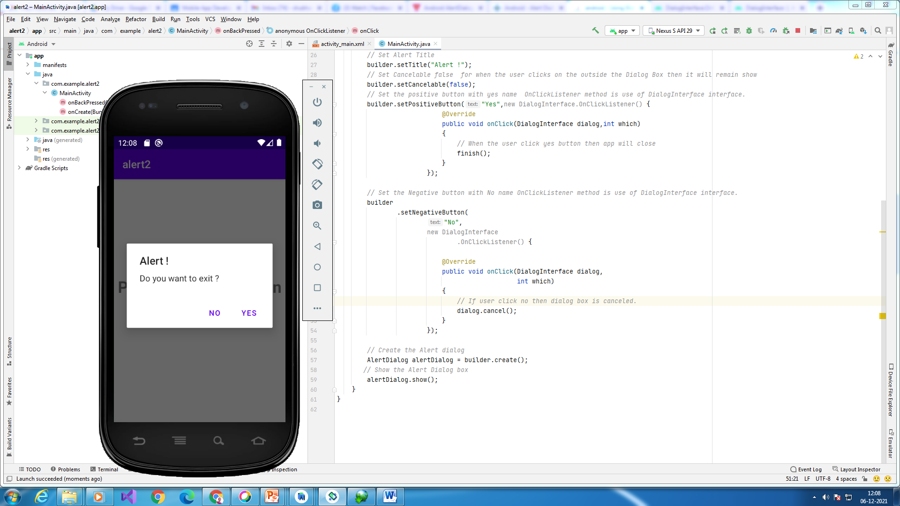

*<?*xml version="1.0" encoding="utf-8"*?>*<RelativeLayout  
 xmlns:android="http://schemas.android.com/apk/res/android"  
 xmlns:app="http://schemas.android.com/apk/res-auto"  
 xmlns:tools="http://schemas.android.com/tools"  
 android:layout_width="match_parent"  
 android:layout_height="match_parent"  
 tools:context=".MainActivity">  
  
 <TextView  
 android:layout_width="wrap_content"  
 android:layout_height="wrap_content"  
 android:text="Press The Back Button of Your Phone."  
 android:textStyle="bold"  
 android:textSize="30dp"  
 android:gravity="center_horizontal"  
 android:layout_marginTop="180dp"  
 />  
  
</RelativeLayout>

package com.example.alert2;  
import androidx.appcompat.app.AlertDialog;  
import androidx.appcompat.app.AppCompatActivity;  
import android.os.Bundle;  
import android.content.DialogInterface;  
public class MainActivity extends AppCompatActivity {  
  
 @Override  
 protected void onCreate(Bundle savedInstanceState)  
 {  
 super.onCreate(savedInstanceState);  
 setContentView(R.layout.*activity_main*);  
 }  
  
 *// Declare the onBackPressed method  
 // when the back button is pressed  
 // this method will call* @Override  
 public void onBackPressed()  
 {  
  
 *// Create the object of AlertDialog Builder class* AlertDialog.Builder builder = new AlertDialog.Builder(MainActivity.this);  
 *// Set the message show for the Alert time* builder.setMessage("Do you want to exit ?");  
 *// Set Alert Title* builder.setTitle("Alert !");  
 *// Set Cancelable false for when the user clicks on the outside the Dialog Box then it will remain show* builder.setCancelable(false);  
 *// Set the positive button with yes name OnClickListener method is use of DialogInterface interface.* builder.setPositiveButton("Yes",new DialogInterface.OnClickListener() {  
 @Override  
 public void onClick(DialogInterface dialog,int which)  
 {  
 *// When the user click yes button then app will close* finish();  
 }  
 });  
  
 *// Set the Negative button with No name OnClickListener method is use of DialogInterface interface.* builder  
 .setNegativeButton(  
 "No",  
 new DialogInterface  
 .OnClickListener() {  
  
 @Override  
 public void onClick(DialogInterface dialog,  
 int which)  
 {  
 *// If user click no then dialog box is canceled.* dialog.cancel();  
 }  
 });  
  
 *// Create the Alert dialog* AlertDialog alertDialog = builder.create();  
 *// Show the Alert Dialog box* alertDialog.show();  
 }  
}

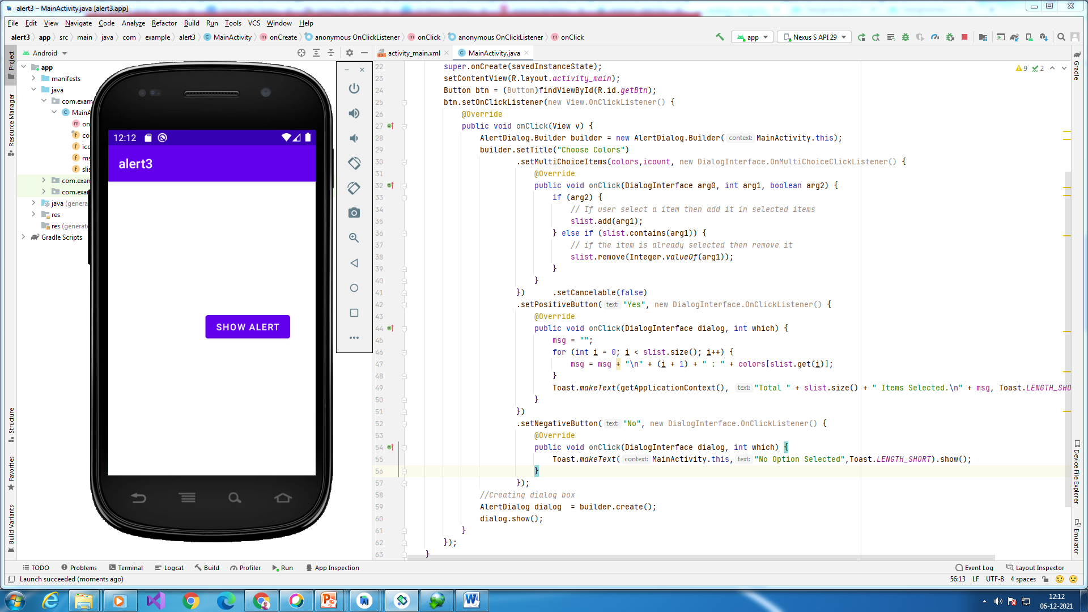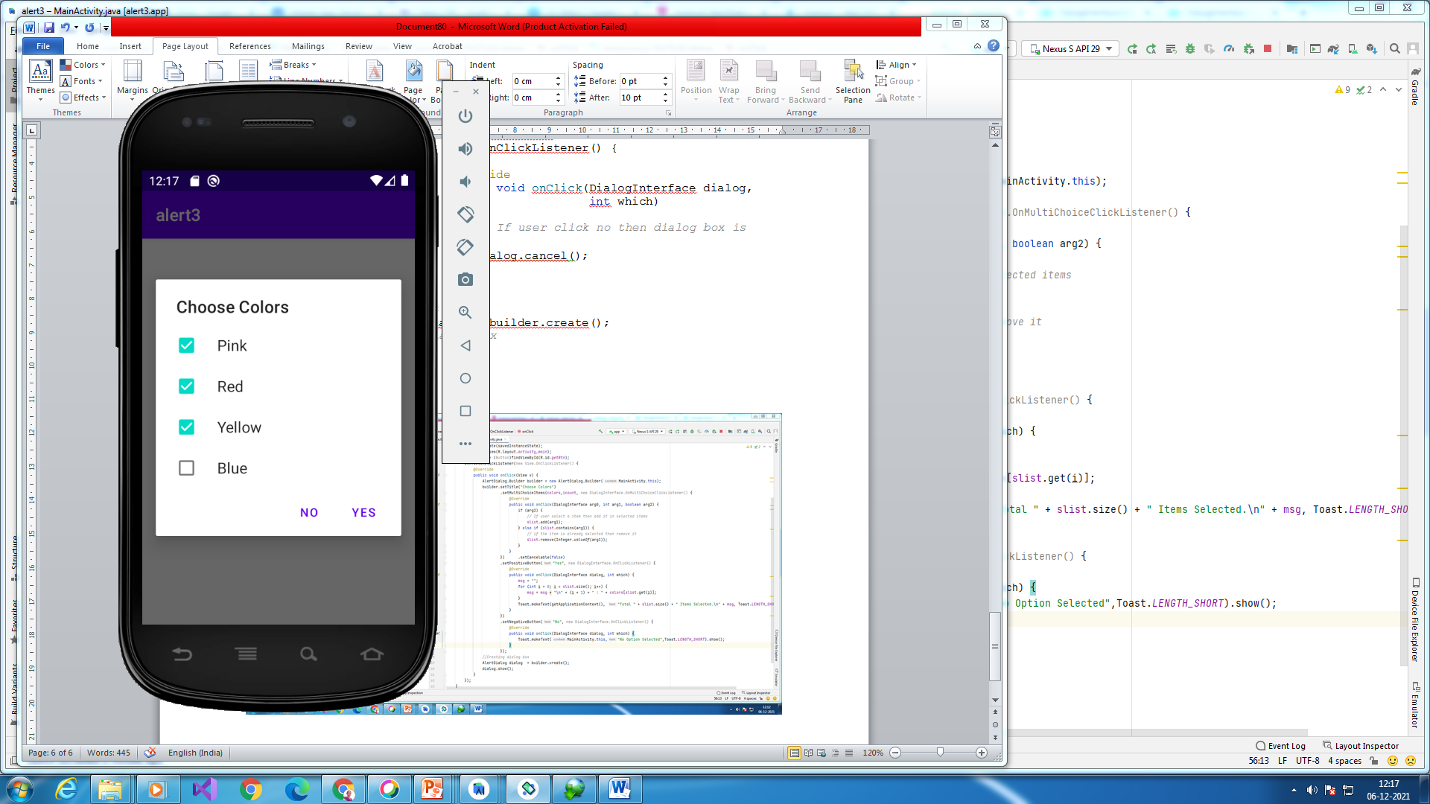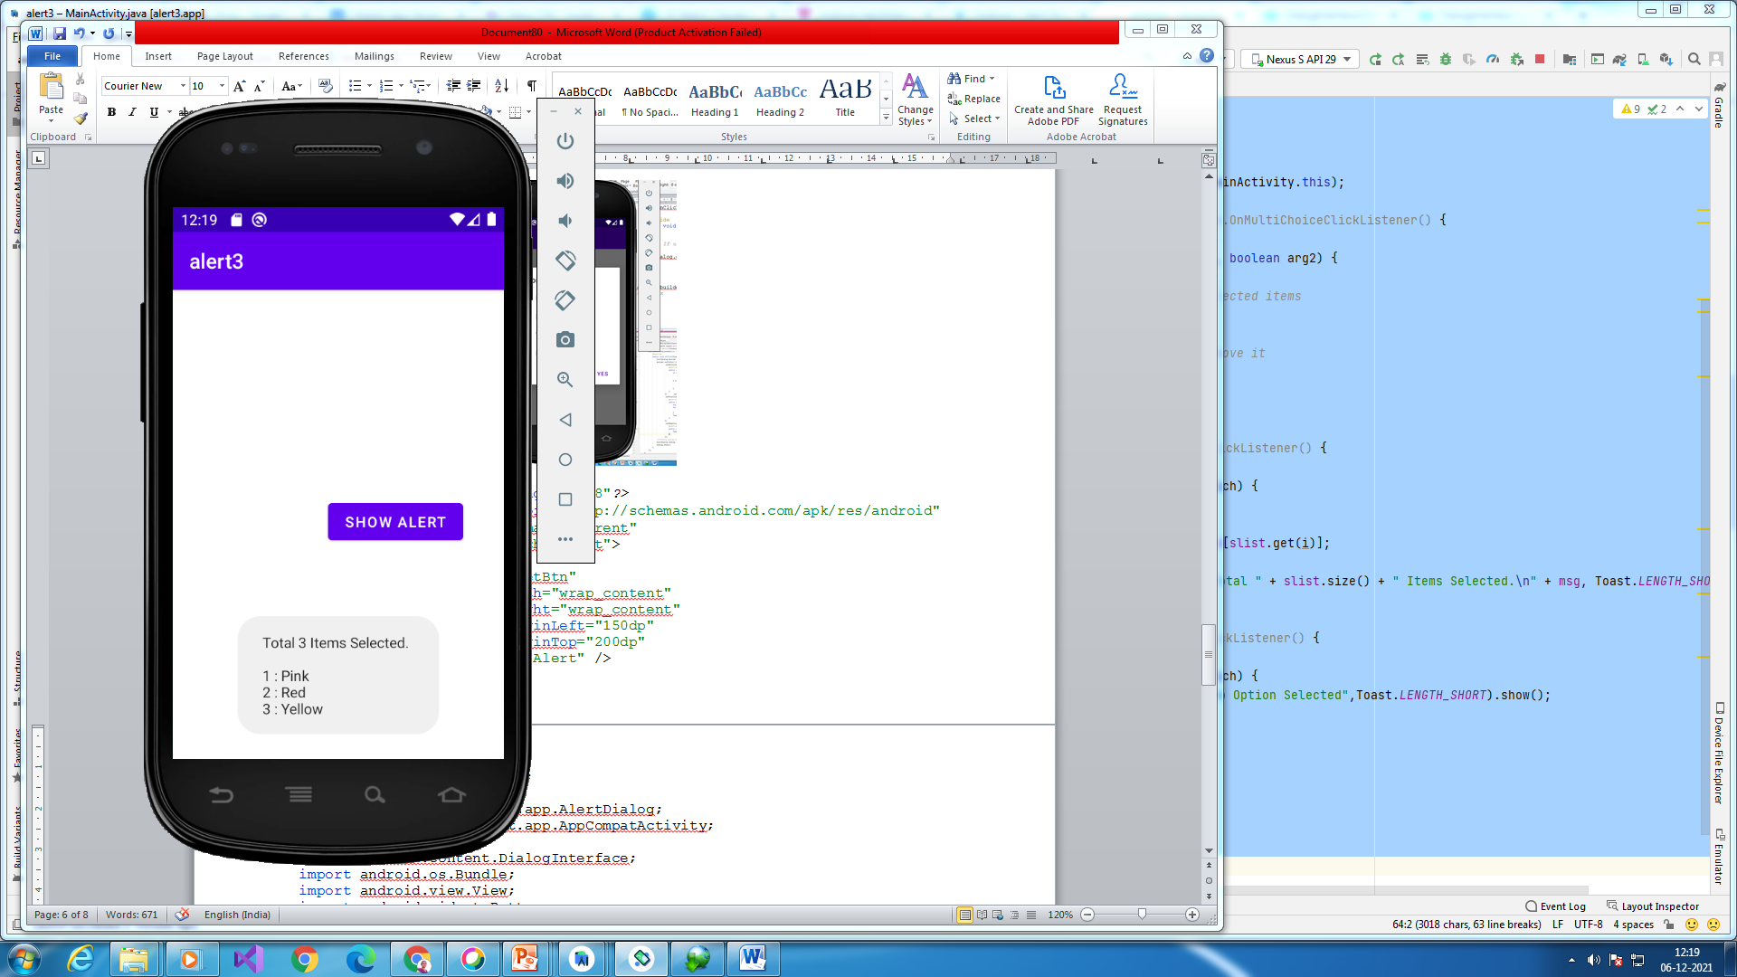

*<?*xml version="1.0" encoding="utf-8"*?>*<RelativeLayout xmlns:android="http://schemas.android.com/apk/res/android"  
 android:layout_width="match_parent" android:layout_height="match_parent">  
 <Button  
 android:id="@+id/getBtn"  
 android:layout_width="wrap_content"  
 android:layout_height="wrap_content"  
 android:layout_marginLeft="150dp"  
 android:layout_marginTop="200dp"  
 android:text="Show Alert" />  
</RelativeLayout>

package com.example.alert3;  
  
import androidx.appcompat.app.AlertDialog;  
import androidx.appcompat.app.AppCompatActivity;  
  
import android.content.DialogInterface;  
import android.os.Bundle;  
import android.view.View;  
import android.widget.Button;  
import android.widget.Toast;  
  
import java.util.ArrayList;  
  
public class MainActivity extends AppCompatActivity {  
  
 final CharSequence[] colors = { "Pink", "Red", "Yellow", "Blue" };  
 ArrayList<Integer> slist = new ArrayList();  
 boolean icount[] = new boolean[colors.length];  
 String msg ="";  
 @Override  
 protected void onCreate(Bundle savedInstanceState) {  
 super.onCreate(savedInstanceState);  
 setContentView(R.layout.*activity_main*);  
 Button btn = (Button)findViewById(R.id.*getBtn*);  
 btn.setOnClickListener(new View.OnClickListener() {  
 @Override  
 public void onClick(View v) {  
 AlertDialog.Builder builder = new AlertDialog.Builder(MainActivity.this);  
 builder.setTitle("Choose Colors")  
 .setMultiChoiceItems(colors,icount, new DialogInterface.OnMultiChoiceClickListener() {  
 @Override  
 public void onClick(DialogInterface arg0, int arg1, boolean arg2) {  
 if (arg2) {  
 *// If user select a item then add it in selected items* slist.add(arg1);  
 } else if (slist.contains(arg1)) {  
 *// if the item is already selected then remove it* slist.remove(Integer.*valueOf*(arg1));  
 }  
 }  
 }) .setCancelable(false)  
 .setPositiveButton("Yes", new DialogInterface.OnClickListener() {  
 @Override  
 public void onClick(DialogInterface dialog, int which) {  
 msg = "";  
 for (int i = 0; i < slist.size(); i++) {  
 msg = msg + "\n" + (i + 1) + " : " + colors[slist.get(i)];  
 }  
 Toast.*makeText*(getApplicationContext(), "Total " + slist.size() + " Items Selected.\n" + msg, Toast.*LENGTH_SHORT*).show();  
 }  
 })  
 .setNegativeButton("No", new DialogInterface.OnClickListener() {  
 @Override  
 public void onClick(DialogInterface dialog, int which) {  
 Toast.*makeText*(MainActivity.this,"No Option Selected",Toast.*LENGTH_SHORT*).show();  
 }  
 });  
 *//Creating dialog box* AlertDialog dialog = builder.create();  
 dialog.show();  
 }  
 });  
 }  
}

Example 4:

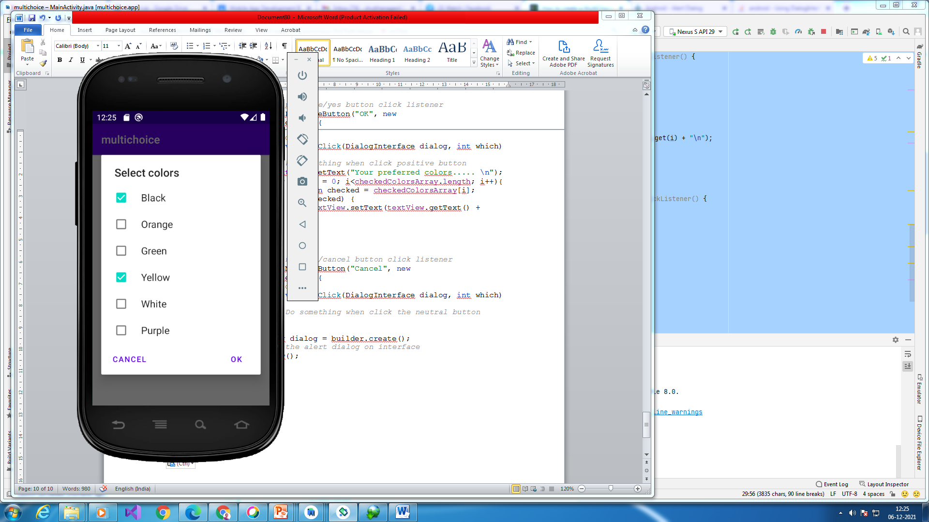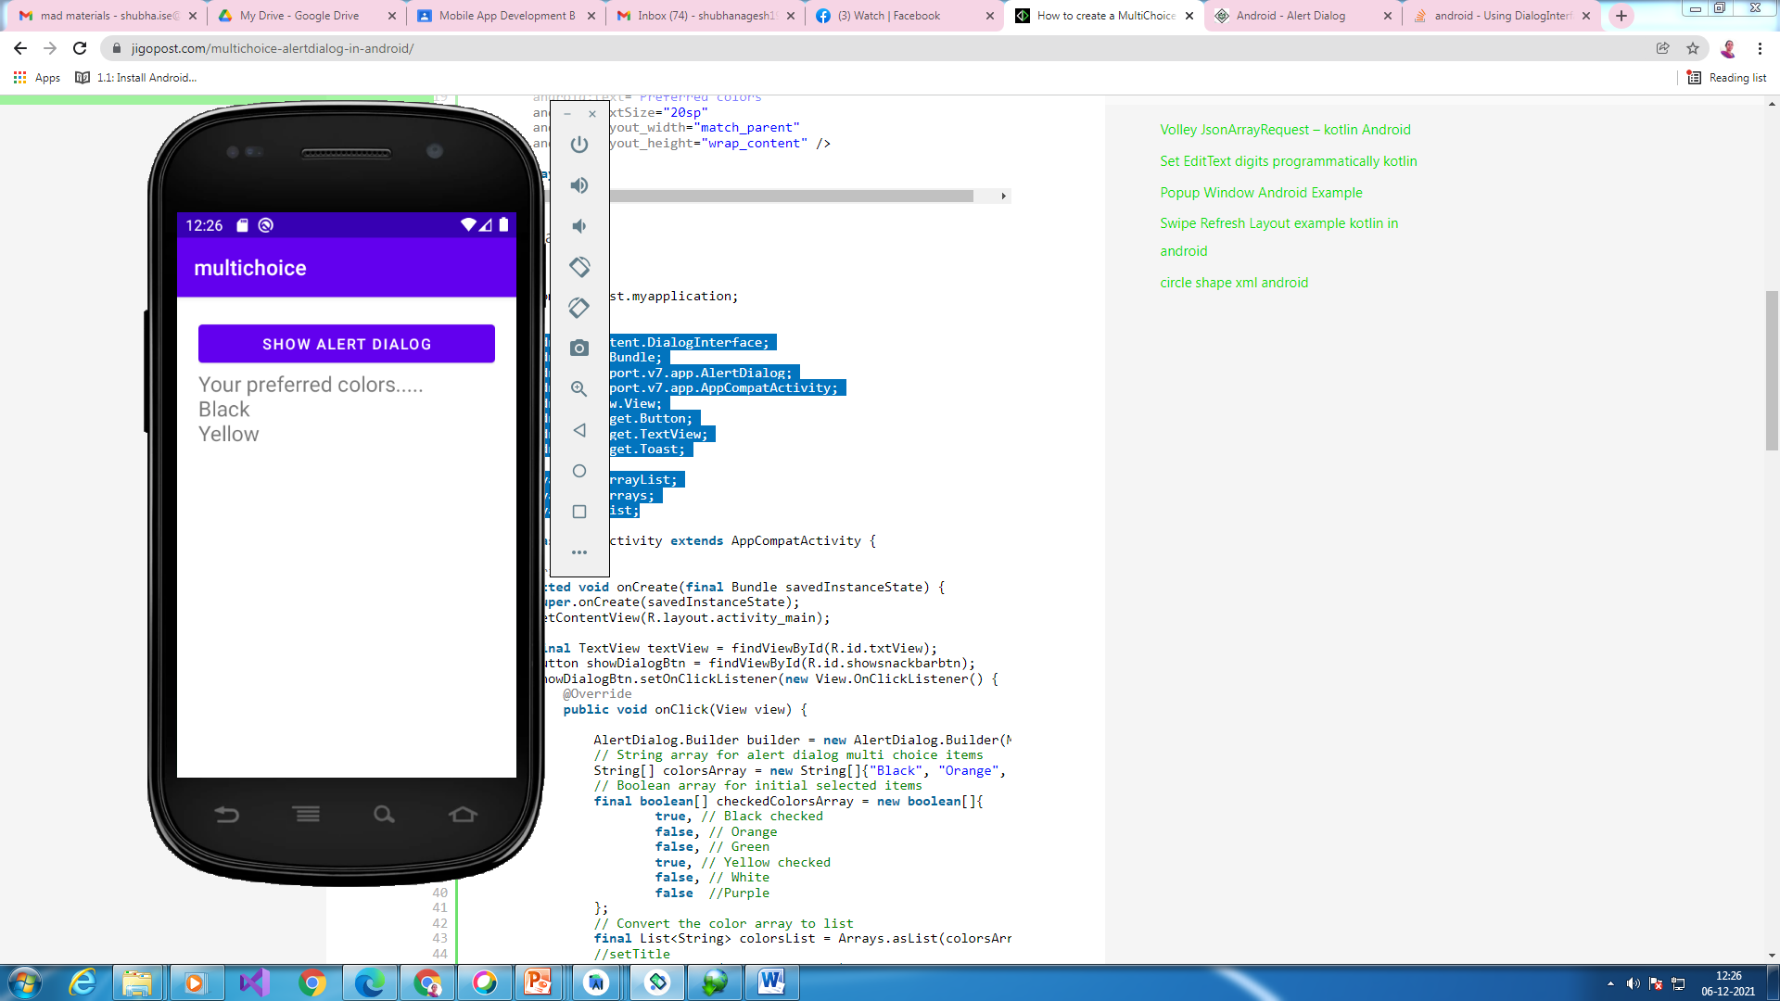

*<?*xml version="1.0" encoding="utf-8"*?>*<LinearLayout xmlns:android="http://schemas.android.com/apk/res/android"  
xmlns:app="http://schemas.android.com/apk/res-auto"  
xmlns:tools="http://schemas.android.com/tools"  
android:layout_width="match_parent"  
android:layout_height="match_parent"  
android:padding="20dp"  
android:orientation="vertical"  
tools:context=".MainActivity">  
  
<Button  
 android:id="@+id/showsnackbarbtn"  
 android:text="Show Alert Dialog"  
 android:layout_width="match_parent"  
 android:layout_height="wrap_content" />  
  
<TextView  
 android:id="@+id/txtView"  
 android:text="Preferred colors"  
 android:textSize="20sp"  
 android:layout_width="match_parent"  
 android:layout_height="wrap_content" />  
  
</LinearLayout>

package com.example.multichoice;  
  
import android.content.DialogInterface;  
import android.os.Bundle;  
import android.view.View;  
import android.widget.Button;  
import android.widget.TextView;  
import android.widget.Toast;  
  
import androidx.appcompat.app.AlertDialog;  
import androidx.appcompat.app.AppCompatActivity;  
  
import java.util.Arrays;  
import java.util.List;  
  
public class MainActivity extends AppCompatActivity {  
  
 @Override  
 protected void onCreate(final Bundle savedInstanceState) {  
 super.onCreate(savedInstanceState);  
 setContentView(R.layout.*activity_main*);  
  
 final TextView textView = findViewById(R.id.*txtView*);  
 Button showDialogBtn = findViewById(R.id.*showsnackbarbtn*);  
 showDialogBtn.setOnClickListener(new View.OnClickListener() {  
 @Override  
 public void onClick(View view) {  
  
 AlertDialog.Builder builder = new AlertDialog.Builder(MainActivity.this);  
 *// String array for alert dialog multi choice items* String[] colorsArray = new String[]{"Black", "Orange", "Green", "Yellow", "White", "Purple"};  
 *// Boolean array for initial selected items* final boolean[] checkedColorsArray = new boolean[]{  
 true, *// Black checked* false, *// Orange* false, *// Green* true, *// Yellow checked* false, *// White* false *//Purple* };  
 *// Convert the color array to list* final List<String> colorsList = Arrays.*asList*(colorsArray);  
 *//setTitle* builder.setTitle("Select colors");  
 *//set multichoice* builder.setMultiChoiceItems(colorsArray, checkedColorsArray, new DialogInterface.OnMultiChoiceClickListener() {  
 @Override  
 public void onClick(DialogInterface dialog, int which, boolean isChecked) {  
 *// Update the current focused item's checked status* checkedColorsArray[which] = isChecked;  
 *// Get the current focused item* String currentItem = colorsList.get(which);  
 *// Notify the current action* Toast.*makeText*(getApplicationContext(), currentItem + " " + isChecked, Toast.*LENGTH_SHORT*).show();  
 }  
 });  
 *// Set the positive/yes button click listener* builder.setPositiveButton("OK", new DialogInterface.OnClickListener() {  
 @Override  
 public void onClick(DialogInterface dialog, int which) {  
 *// Do something when click positive button* textView.setText("Your preferred colors..... \n");  
 for (int i = 0; i<checkedColorsArray.length; i++){  
 boolean checked = checkedColorsArray[i];  
 if (checked) {  
 textView.setText(textView.getText() + colorsList.get(i) + "\n");  
 }  
 }  
 }  
 });  
 *// Set the neutral/cancel button click listener* builder.setNeutralButton("Cancel", new DialogInterface.OnClickListener() {  
 @Override  
 public void onClick(DialogInterface dialog, int which) {  
 *// Do something when click the neutral button* }  
 });  
 AlertDialog dialog = builder.create();  
 *// Display the alert dialog on interface* dialog.show();  
  
 }  
 });  
  
  
 }  
  
  
  
  
}